**Project Planning Tool: Task-Level Information Template**

Project Title: **Sustainability Dashboard**

Task Title: **Ecosystem Services Report Card**

Task Lead: **Allen Brookes**

Task Start Date: April 2015

Task End Date: September 2016 (?)

**Task Description:** Through development of the ecosystem services report card tool, we hope to (1) develop and demonstrate a mechanism to elicit a list of community beneficiaries, identify the measures of ecosystem services relevant to those beneficiaries, and create a status report of how ecosystem services are faring with regards to beneficiary values (poor, fair, good), and (2) develop a mechanism for collecting data about preferences for ecosystem services for local services.

We hope to achieve three goals in our design: create a tool that helps communities define beneficiaries and identify the status of ecosystem services valuable to those beneficiaries in those communities; create a report that seamlessly fits the current work flow of decision making processes in a variety of communities for wider adoption; and provide useful information for the purposes and context of local decision making processes. Additionally, we hope that wider adoption the Ecosystem Services Report Card will serve as proof of concept for using metrics and indices of final ecosystem goods and services in local decision making.

**Research Approach:** Over the course of its development, prototypes of the Report Card will be tested in pilot communities already partnering with the SHC 2.61 researchers.

Prior to development, Federal Case Study Leads of SHC 2.61 with ties to communities will be asked for information about the science they are conducting and the types of decisions and public policy processes the science is being used for. The report card developers will gather this information about scientific research, decision types, and policy processes either through informal interviewing, project documents, or through brief, online questionnaires prior to starting development of the report card. This information will be used to design the software architecture.

After collecting background information from Federal Case Study Leads, the development team will create the initial software design. Initial design will be in the form of an Excel spreadsheet. Once this initial design is completed, Federal Case Study Leads with ties to case study communities (i.e., people like Bob McKane) will be asked to provide inputs for the various subtasks of the report card tool as part of a testing protocol administered by the development team (i.e., people like Kirsten Winters or Paul Ringold). Federal Case Study Leads may choose their level of involvement in testing this initial design. The Federal Case Study Leads’ involvement might range from completing the tasks to providing information about case study communities so that the development team might complete the tasks, instead. The tasks the user will complete are:

Task 1: Identify the list of how people benefit from ecosystem services specific to the case study community. This list of community-specific beneficiaries will be generated by the user manually adding beneficiaries. This list of beneficiaries will refer to the FEGS-CS for suggestions of potential beneficiary types. Beneficiaries might include anglers and boaters, for example.

Task 2: Generate a list of final ecosystem goods and services directly related to the various people using them. These goods and services might be listed as an aggregated bundle. For example, identifying the goods and services valued by an angler during a day of fishing might include fish presence, abundance, and site aesthetics. A boater might also value services such as site aesthetics, fish presence, but also channel width and depth. Complementary goods and other management concerns, such as access roads and crowding, should not be listed as a final ecosystem good and service. To be sure, there is a necessary subjectivity involved in determining what is valuable to a community and the local conditions for serving the needs and preferences of varying beneficiaries. When completing the tasks, the user takes into account the conditions and values of a specific community.

Using the inputs, a report will be generated showing the overall status of the ecosystem service in relation to the local values for that service. As mentioned earlier, this output is unique to the preferences and values of a specific community and dependent on management priorities.

Over the course of development (three distinct prototype and evaluation points), expert opinion and scientific research of Federal Case Study Leads plays an important role in helping to establish the indicator of relative ecosystem health in both the short- and long-term. Case study analysis will inform development of prototypes 1 and 2, so that community managers might be able to list beneficiaries and preferences, themselves, and generate a status report for informing decision making processes. The Report card shows how communities value certain qualities of the ecosystem, but may be dissatisfied with the current status of that ecosystem.

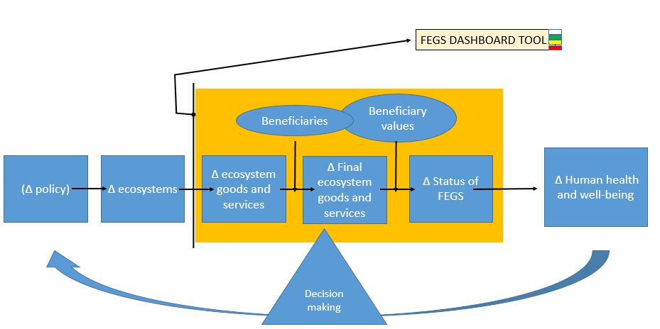

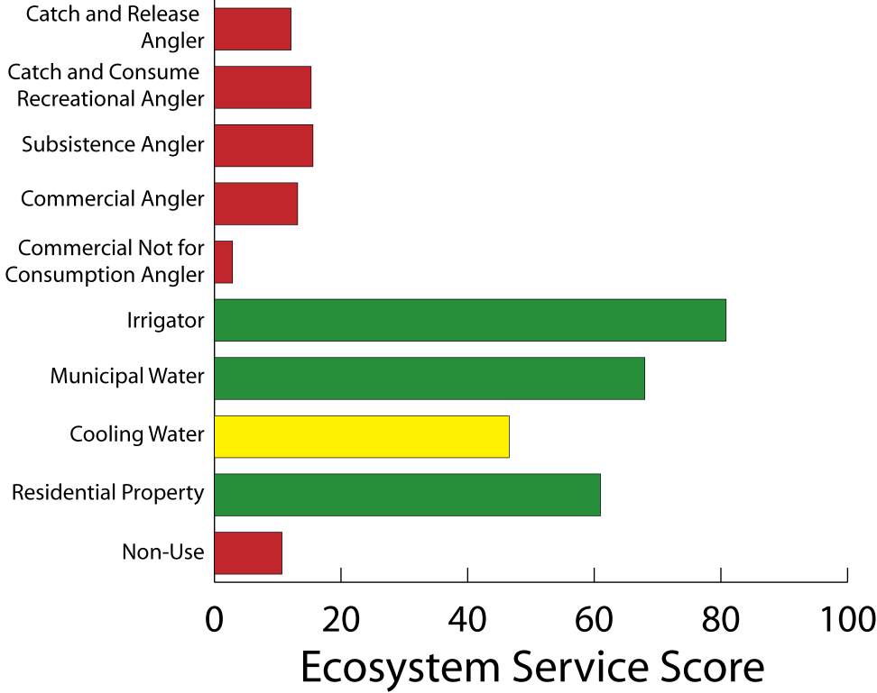

**Figure 1: A mock-up of the report card is shown here. More detail behind the numbers will be provided over the course of the report card development. Additionally, design of the interface will be completed during the design process. The report card can be used to create a custom report based on the local preferences of beneficiaries and the relative health of ecosystems for providing valued services. This status report might be used as a guide to communities for seeking information and models about the outcomes of different management choices. It might also be used as a way to understand how benefits transfer across communities.**

During the testing phases of the report card, the input of the Federal Case Study Leads will include information that might have been overlooked by developers. For example, the Report card may show that a 100 meter riparian zone will suit the needs of beneficiaries in the short-term, yet a Federal Case Study Lead might know through modeled outcomes that certain weather events associated with climate change predications might require increasing the buffer zone to 200 meters to suit the long-term preferences of a local community. Different management options can then be explored via scientific models, such as the long-term effectiveness of various areas of riparian buffer zones. Therefore, the Report card works as a first step for identifying the metrics and indicators of FEGS that need to be modeled by scientists. To be sure, articulating this status report seems a necessary first step in guiding communities to scientific models for informing decisions.

**Task Constraints:**

1. Development is dependent on the hiring of a contractor in charge of technical aspects, such as physically implementing design over the course of development.
2. Understanding of the broad range of users will require research and iterative development, which will take time. Additionally, this project requires the partnership and buy-in of case study leads.

*Define scientific, logistical, and technical constraints associated with completing the Task*

*Availability of appropriate tools*

*Availability to data to run the tools for decision making*

*Ability of communities to use the developed tools*

**Task Dependencies:**

**Task Quality Assurance and Data Management Needs**:

* Is there an existing IRP/ QAPP(s) that applies to this Task? If so, identify IRP/QAPP. If new IRP/QAPPs are required, provide the status.
* Will this Task involve large amounts of data that need a data management plan? If yes, explain

**Task Products:**

|  |  |  |  |
| --- | --- | --- | --- |
|  |  |  |  |
| * Product Title | **Prototype 1** | **Prototype 2** | **Prototype 3** |
| * Product Contact (email) | **Winters.kirsten@epa.gov** |  |  |
| * Product’s Delivery Date | **6 weeks after hire of technical support/contractor** | **3 months after prototype 1 is tested** | **4 months after prototype 2 is tested** |
| * Product Description * Product’s Contribution to Output | Working spreadsheet 🡪  Initial operational design of software tool; software tool backend development) version 1 | Desktop version of the tool 🡪  Final operational design of software tool; Initial design of interface; related use cases | **Improved desktop tool or web tool 🡪**  **Proof of concept for use in decision support settings: final design will be evaluated to understand 🡪 use/usefulness of (1) the tool; and (2) report card for decision support** |
| Product’s Timeline | 5/15-6/15 Draft operational design of software tool; elicit written feedback  6/15 - 9/15 Finalize operational design of software tool; Contact and confirm case study communities; Develop protocol for testing and data collection to use in case study communities | TBD: Draft interface design; complete backend coding and development; elicit feedback; execute protocol for testing and data collection to use in case study communities; propose and execute design improvements based on testing | TBD: |
| * Product’s intended user/customer/audience | **Managers, decision makers, and constituencies** | **Managers, decision makers, and constituencies** | **Managers, decision makers, and constituencies** |
| * Is this a key product? | **Yes** | **Yes** | **yes** |
| * Does this Product contribute to a Product under another Task? If so, identify other Task | **Yes—this spreadsheet is the prototype to inform design and development of final Report Card** | **Yes—this desktop design and functionality will provide the baseline for final product** | **Yes—this final version of the report card may be incorporated into a suite of other tools for decision making** |

**Task Resources:**

Task Level Extramural Resources

*In the following section you will need to lay out the recommended funding allocations for sub-elements of the Project. The total amount should equal no more than the extramural allocation agreed upon in the Project Charter. Separate fields are provided for each year's allocation.*

Lab or Center receiving money:

Division:

Contact name:

Extramural (NPD RAP) in $K

* FY15:
* FY16:150k
* FY17:150k

Description of Extramural needs for each FY:

*What science efforts are the funds needed for? Is there specific timing (i.e., contracts)?*

***Software development***

***Data collection***

Description of impact on Product delivery (or contribution) if resources are not available in a timely manner?

*Be specific and reference individual Products*

Proposed method for Extramural Need

*Chose from:*

*Contracts;*

*Technical Service Contract;*

*Senior Employee SEE;*

*Training Agreements (Student Service Contracts, NRC Post Doc Program, ORISE);*

*Interagency Agreements;*

*Grant/Assistance;*

*Federal Technology Transfer Act Program*

Task Level Intramural Resources

*This need not be a detailed allocation of itemized costs, but should focus more on "big ticket" supplies and expense costs associated with conducting this specific task. Division management must agree to commit the listed resources for the project. Descriptions should provide information on what the funds are needed for, pertinent information on when resources are required for the plan, how they will be used, and the product (or product contribution) impact if resources are not available in a timely manner. Separate columns are provided for each year's allocation.*

Intramural (L/C Corporate) in $K

* FY15:
* FY16:
* FY17:

Description of Intramural Needs for each FY

Special Task Level Resource Needs and Considerations

Special facilities or equipment needed:

Identify any of the following that apply:

* High performance computing/visualization
* Regional Applied Research Effort (RARE)
* Regional Methods (RM)
* Pathfinder Innovation Project (PIP)
* Tech transfer/CRADAs
* Requires Significant Travel (i.e., field studies, site visits, etc)

**Task Staffing:**

|  |  |  |  |  |  |  |  |
| --- | --- | --- | --- | --- | --- | --- | --- |
| Staff Member | L/C | Division | Expertise | Contribution to Project or Task | FY15 % FTE | FY16 % FTE | FY17 % FTE |
| Allen Brookes |  |  | Supervisor, Technical Lead |  |  |  |  |
| Kirsten Winters |  |  | Content lead and Project Management |  |  |  |  |
| Student Contractor |  |  | Technical support and software development |  |  |  |  |
| Paul Ringold |  |  | Supervisor, Content Support |  |  |  |  |
|  |  |  |  |  |  |  |  |
|  |  |  |  |  |  |  |  |
|  |  |  |  |  |  |  |  |
|  |  |  |  |  |  |  |  |